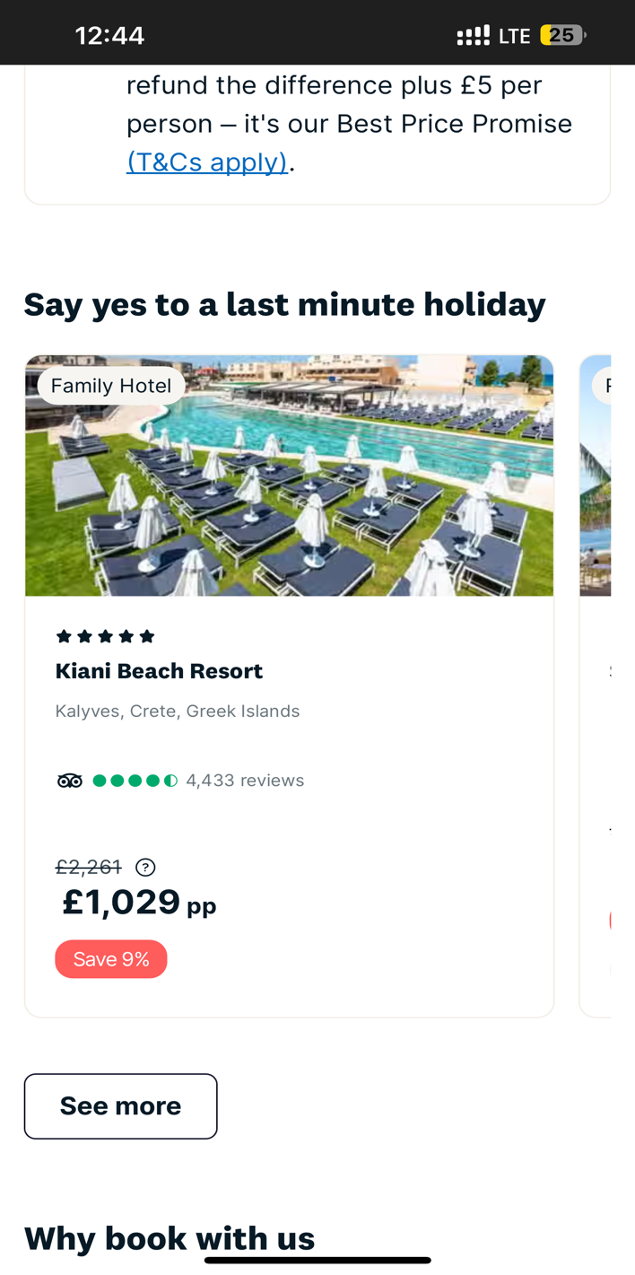**Sample / Template**

## Here is the New Holiday Package, for your simplicity in the brackets the content refer to what is in the reference image attached above

**Santorini, Greece (Kiani Beach Resort)**

* Location: Oia, Santorini, Greek Islands (Kalyvers, Crete, Grek Islands)
* Type: Seaside Budget Hotel (Family Hotel)
* Rating: ★★★★☆ (4 stars) (5 Stars)
* Number of Reviews: 2,317 (Tripadvisor) ()
* Original Price: £410 per person (2,261)
* Discounted Price: £349 per person (1,029)
* Discount: Save 15% (9%)

Add ‘See Availability’ on right side of ‘save 9%’

And when we click on that button it should open a page which is same as getvisanow page, but on that page there should be flight inquiry form which is same as on the main page, below is the image attached

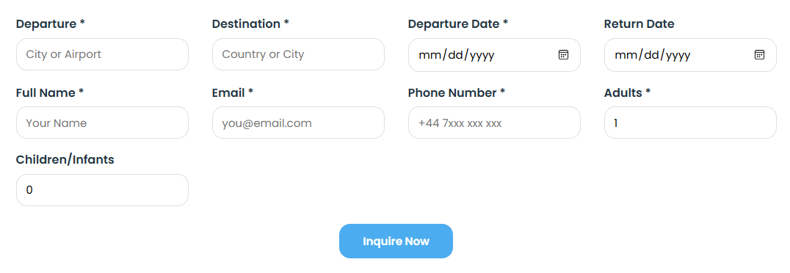

**Heading: Holiday Packages To Add In Holidays Packages Section**

**Santorini, Greece**

* Location: Oia, Santorini, Greek Islands
* Type: Seaside Budget Hotel
* Rating: ★★★★☆ (4 stars)
* Number of Reviews: 2,317 (Tripadvisor)
* Original Price: £410 per person
* Discounted Price: £349 per person
* Discount: Save 15%

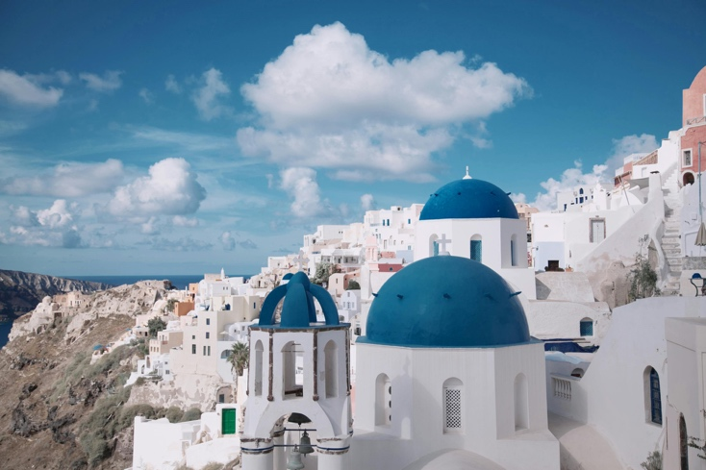

**Paris, France**

* Location: Montmartre, Paris
* Type: Boutique City Hotel
* Rating: ★★★★☆ (4 stars)
* Number of Reviews: 3,842 (Tripadvisor)
* Original Price: £395 per person
* Discounted Price: £325 per person
* 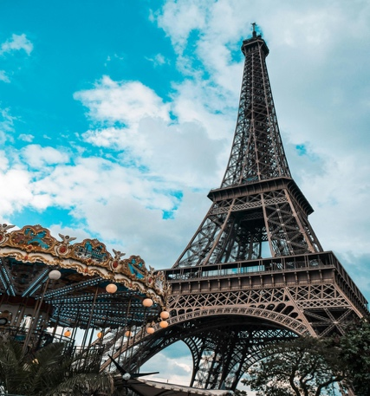Discount: Save 18%

**Venice, Italy**

* Location: Cannaregio, Venice
* Type: Historic Canal-Side Guesthouse
* Rating: ★★★★☆ (4 stars)
* Number of Reviews: 2,607 (Tripadvisor)
* Original Price: £370 per person
* Discounted Price: £295 per person
* Discount: Save 20%

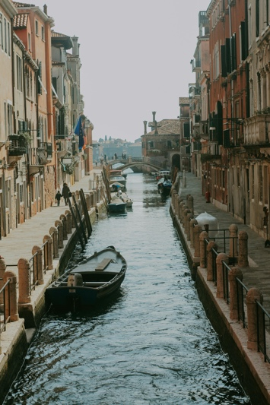

**Barcelona, Spain**

* Location: Gothic Quarter, Barcelona
* Type: Stylish Urban Hotel
* Rating: ★★★★☆ (4 stars)
* Number of Reviews: 3,456 (Tripadvisor)
* Original Price: £390 per person
* Discounted Price: £329 per person
* 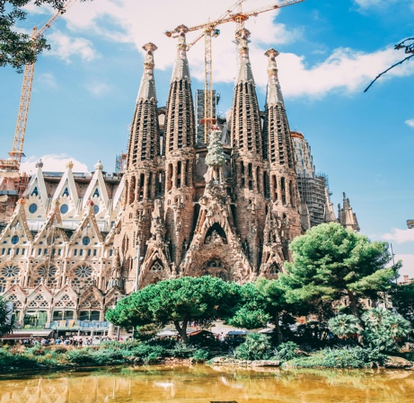Discount: Save 16%

**Amsterdam, Netherlands**

* Location: Jordaan, Amsterdam
* Type: Charming Canal House
* Rating: ★★★★☆ (4 stars)
* Number of Reviews: 2,754 (Tripadvisor)
* Original Price: £360 per person
* Discounted Price: £285 per person
* 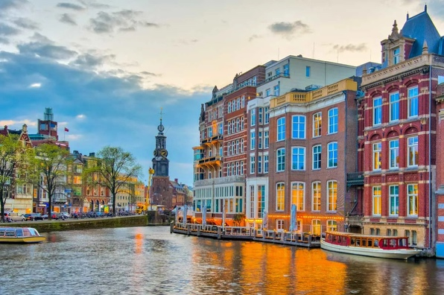Discount: Save 21%

**Geneva, Switzerland**

* Location: Near Lake Geneva
* Type: Cozy City Hotel
* Rating: ★★★★☆ (4 stars)
* Number of Reviews: 2,198 (Tripadvisor)
* Original Price: £415 per person
* Discounted Price: £349 per person
* Discount: Save 16%

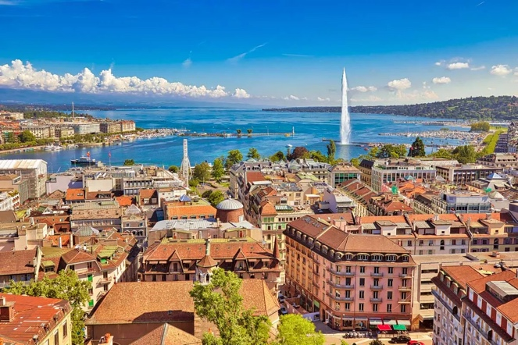

# Change Sub-heading of Slogan

Your gateway to Europe starts here. Visamate makes Schengen visas easy, so you can travel without worries. Trusted by travellers for fast and reliable visa services worldwide

# Change Navbar Button Name ‘Packages’ with ‘Holiday Packages’

# **Choose Your Visa Package ->** CHOSE YOUR VISA SERVICE